Cresote Timbers in Water

Here is a summary of research about creosote timbers in water. Special thanks to Jim of Naglee Park who provided research suggestions.

In 2007, BART planned to tunnel under East Santa Clara Street at Coyote Creek, but the creosote timbers might have been driven too deep. To remove the pilings would be expensive and take a long time to get environmental clearance, so BART chose to go to the north side of East Santa Clara Street. Memos from DOT’s Jim Helmer and Sam Liccardo give insight into the environmental conditions. Napp Fakudua Deputy Director of Environmental Services Watershed Protection was identified as knowlegable on the subject (408)793-5353.

DOT plans to replace the Coyote Creek bridge someday, but they will just cut off the pilings/bents and leave them in the creek. This may be what PRNA will recommend for the Los Gatos Creek bridge.

However, the state Department of Toxic Substance Control conducted formal research on little creosote fragments and fish survival. This would model what would happen if little pieces were left behind when sawing off the pilings. There is 0-20% survival for douglas fir and 60-70% survival for oak.

A freshwater study of oysters showed increased levels of toxic substances 6 months after pulling out the pilings.

Documents Cited

DOT Jim Helmer Memo for Council 2007Nov 20. Item 6.2
BART alignment under Coyote Creek
Page 4 describes problems with alignment under Coyote Creek
http://www3.sanjoseca.gov/clerk/Agenda/112007/112007_06.02sup.pdf

Sam LIccardo’s memo to Council 2007 Dec 11 Council agenda item 6.2
BART tunnel alignment under Coyote Creek.
http://www3.sanjoseca.gov/clerk/Agenda/121107/121107_06.02att.pdf
Page 2 describes Environmental consequences of removing creosote pilings under Coyote Creek/East Santa Clara bridge. From his memo
“I've heard creosote's hazards compared to asbestos; that is, more environmental harm results from the removal of the pilings and the resulting disturbance of nearby soil than allowing the bridge's foundation to remain undisturbed. Accordingly, the state Department of Toxic Substances Control does not recommend removing the pilings. A special thanks to VTA staff, as well as Napp Fakuda.”

Sampling and Analysis Study on Treated Wood
Workshhop presented: 2008 September
Department of Toxic Substance Control, State of California
http://www.dtsc.ca.gov/HazardousWaste/upload/2TWW_Workshop_91108.pdf
Controlled research study took cubes of old creosote-treated railroad ties and calculated fish survival rates. [Note comparison to small broken pieces left behind in creek.]
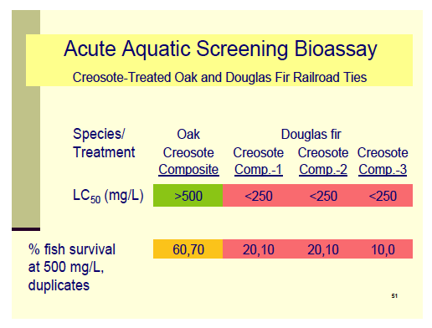

Full report
http://www.dtsc.ca.gov/HazardousWaste/Treated_Wood_Waste.cfm

Napp Fukuda Napp.Fukuda@sanjoseca.gov. P (408) 793-5353.

Pulling out timbers releases harmful chemicals.
Aquat Toxicol. 2008 Jan 31;86(2):287-98. Epub 2007 Nov 17.
Risks to human health and estuarine ecology posed by pulling out creosote-treated timber on oyster farms.
Smith PT.
Source
College of Science and Health, Hawkesbury Campus, Building K12, University of Western Sydney, Locked Bag 1797, Penrith South, NSW 1797, Australia. pt.smith@uws.edu.au
Abstract
Five oyster farms in Port Stephens, Australia were studied to identify consequences of using creosote-treated posts and the risks posed by removing the posts. Gas chromatography coupled with mass spectrometry (GC/MS) was used to measure polycyclic aromatic hydrocarbons (PAHs) and phenols in sediments, timber, water and oyster tissue. Before posts were removed, the total PAHs in surface sediment on farms was 24.1 mgkg(-1) dry weight. This increased to 45.5 mgkg(-1) dry weight after the posts were pulled out and remained significantly higher 6 months later at 59.7 mgkg(-1) dry weight. A similar increase was found in deeper sediments. The sediment attached to creosote-treated posts had a total concentration of PAHs of 484-2642 mgkg(-1) dry weight, while the corresponding value for the sediment on tar-treated posts was only 30.7 mgkg(-1) dry weight. The surface timber of creosote-treated posts had high levels of PAHs and an average post contained 43 g of PAHs. The total PAHs dispersed to the environment when a creosote-treated post was pulled out was at least 0.67 g. The main species were PAHs with low-molecular weights: fluoranthene, phenanthrene, pyrene, acenaphthylene and chrysene. Benzo(a)pyrene represented 1-10% of PAHs in most samples. Bioassays with creosote-contaminated sediment revealed that Sydney rock oysters (Saccostrea glomerate) and Pacific oysters (Crassostrea gigas) accumulated PAHs at (mgkg(-1) wet tissue weight): 11.3-15.3 and 35.5-47.9, respectively, when exposed for 5 days to water with < 1 microgl(-1) PAHs. Wild oysters growing on creosote-treated posts had high levels of phenols (0.09-6.92 mgkg(-1) wet weight) and PAHs (0.59-1.01 mgkg(-1) wet weight). The dilemma posed by removing creosote-treated posts and dispersing carcinogenic, bioavailable contaminants needs to be managed in light of risks to human health and estuarine ecology.
PMID: 18160144 [PubMed - indexed for MEDLINE]
http://www.ncbi.nlm.nih.gov/pubmed/18160144

